STUDENT NAME:MAUREEN WAIRIMU
ADM NO:BSCCS/2025/68877
COURSE:COMPUTER SCIENCE
UNIT TITLE: ETHICAL HACKING
UNIT CODE: BIT 4139.
LECTURER NAME: MR MICHAEL NYORO
SELECTED TOOL:NMAP.

Contents
WEEK ONE: 3
Fig1:Setting up environment variables 3
Fig2:Nmap installed 3
Fig 3:Ping scan Address 192.168.1.0/24 4
Fig4:Port scanning:192.168.1.50 5
Fig5:Footprinting 5
Student reflection: 5
STEPS IN ETHICAL HACKING 5
IDENTIFYING TARGET INSTITUTION 5
Domain information: 6
Subdomains: 6
Domain registrar 6
IP Address 7
Email patterns 7
Technologies running: 8
Leaked credentials: 8
Student reflection 8
Findings 9
Security Risks 9
Task 2 9
SCANNING AND ENUMARATION 9
Scanning ports: 9
OS version scan: 10
Student reflection 12

WEEK ONE:
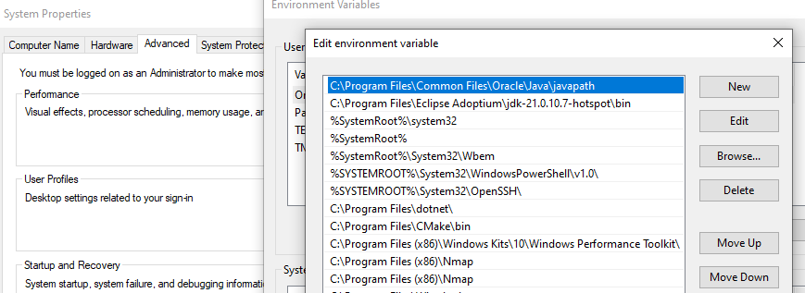
Fig1:Setting up environment variables.
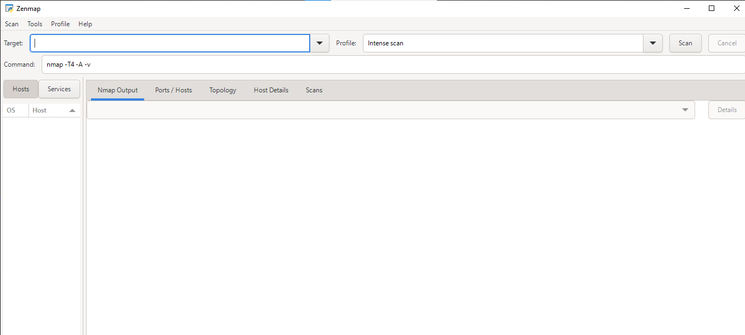
Fig2:Nmap installed.
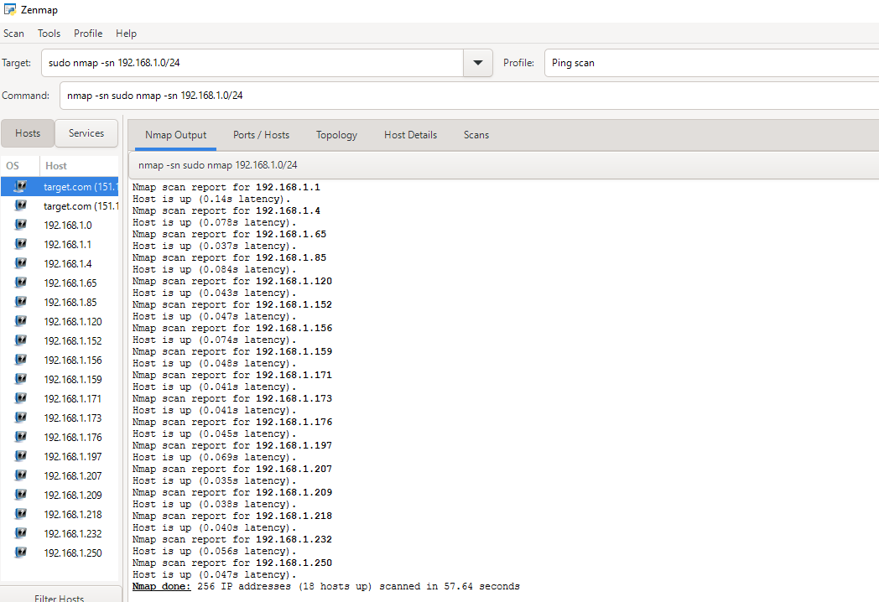

Fig 3:Ping scan Address 192.168.1.0/24
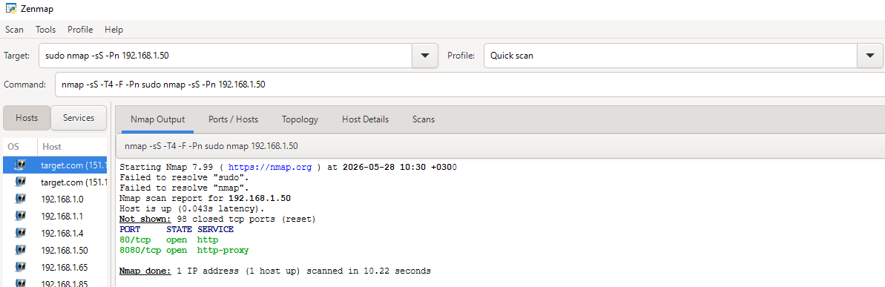

Fig4:Port scanning:192.168.1.50
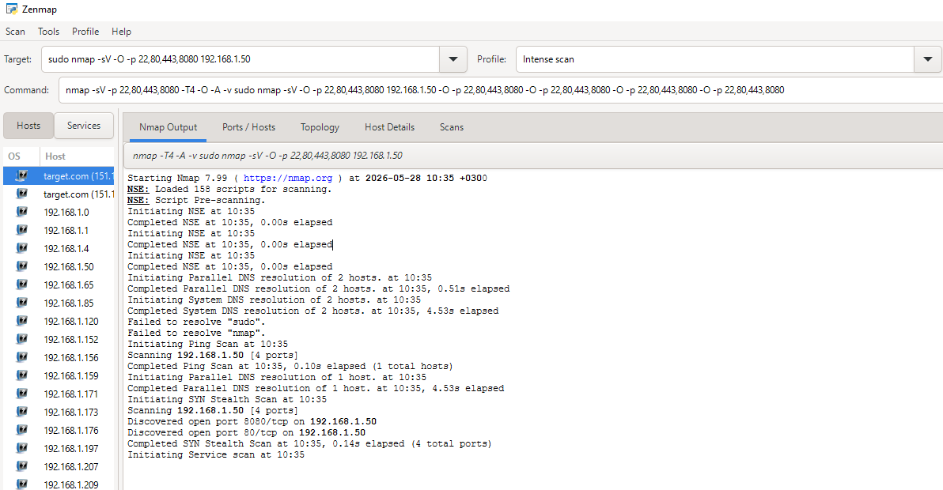

Fig5:Footprinting

Student reflection:
What I have learnt while in week one is how to set up a penetration tool,perform basic scans using ip address and determine the output given .
STEPS IN ETHICAL HACKING.
IDENTIFYING TARGET INSTITUTION.

Domain information:
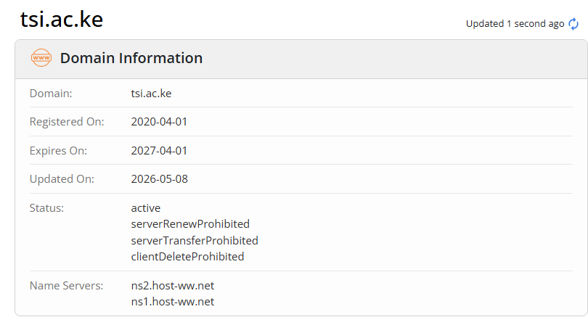

Subdomains:
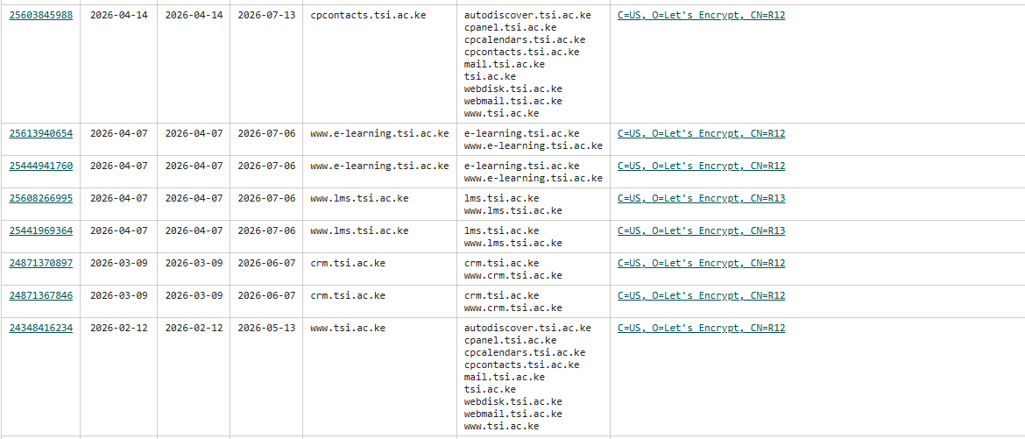
Domain registrar:
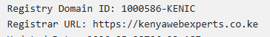

IP Address
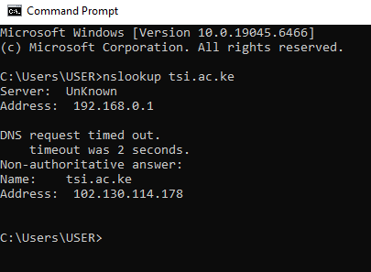

Email patterns
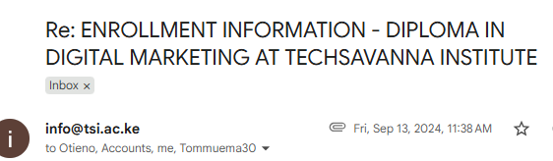

Technologies running:
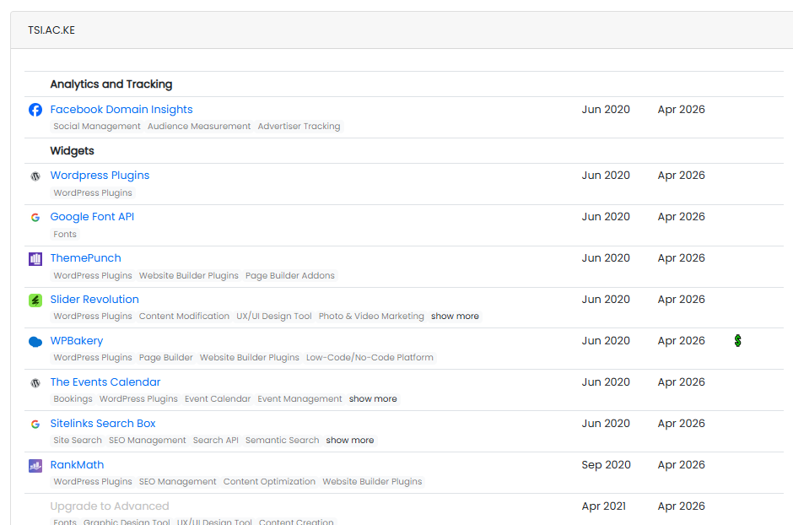

Leaked credentials:
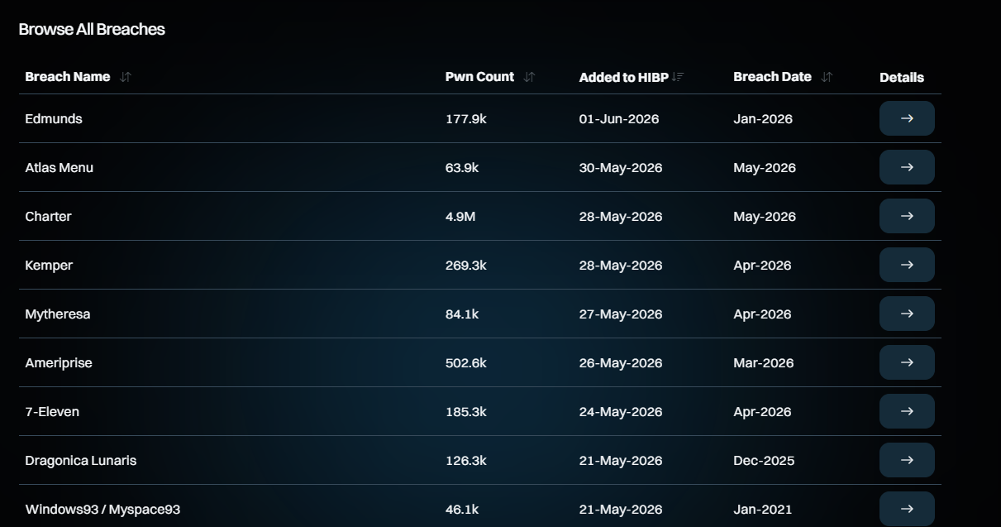
Student reflection:
What I have learnt while perfoming task one is how to gather information from publicly accessible tools such as WHOIS,OSNIT which provides details such as domain registrar ,ip address and others.This helps you understand the system better such as when it was registered,updated and when it expires.This helps one find opportunities for vulnerabilities recognize the patterns.All this basically help the hacker get their objectives in place.

Findings
- Domain and IP publicly accessible.
- Predictable email format
- Technologies identified through headers and nmap scans

Security Risks
- Predictable email format increases risk
- Subdomains may have weaker security controls.

Task 2

SCANNING AND ENUMARATION

Scanning ports:
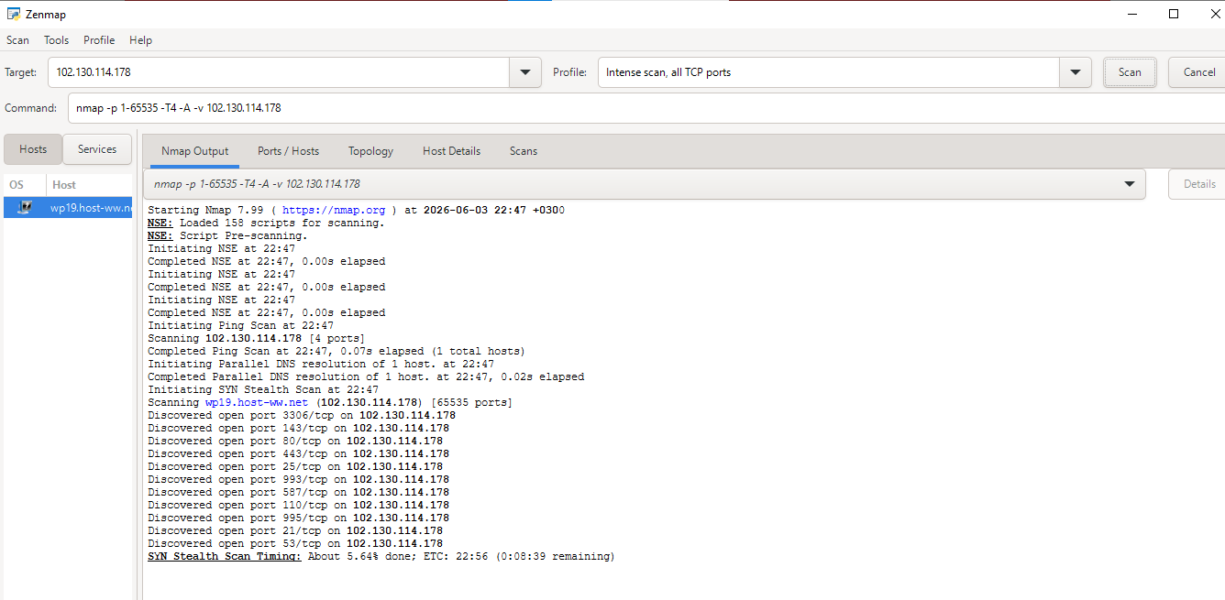

OS version scan:
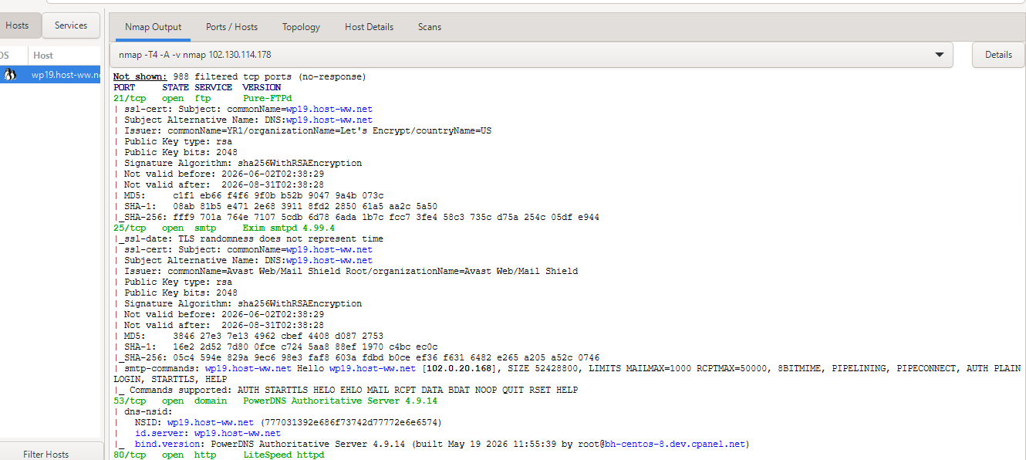
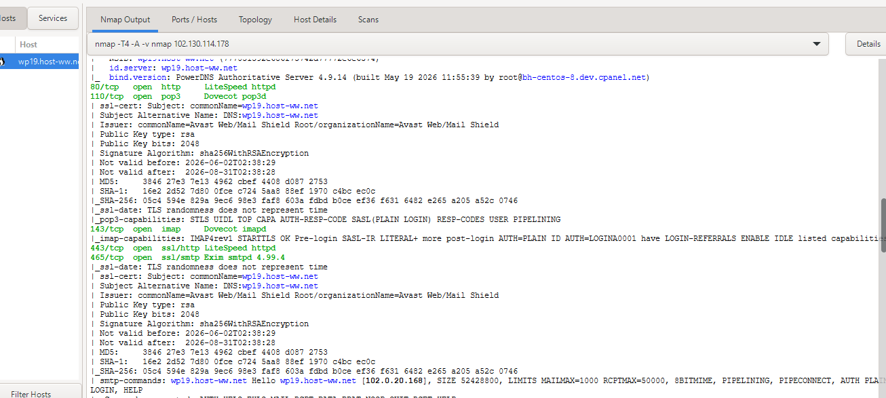
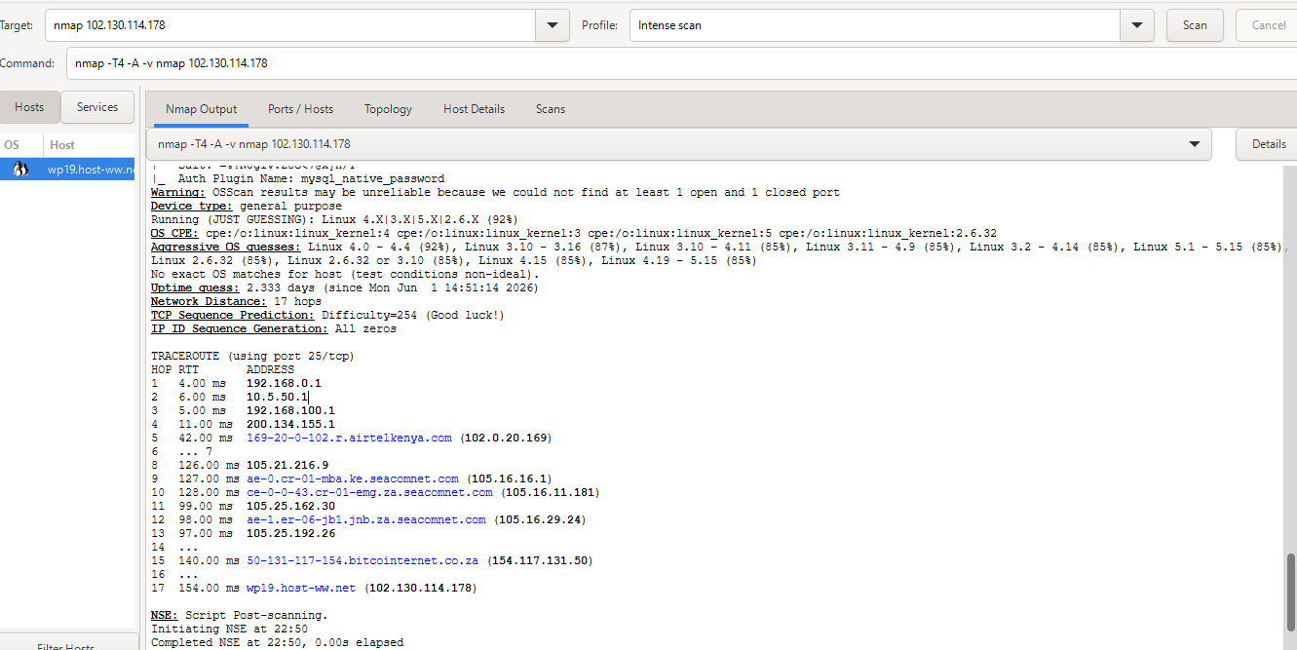
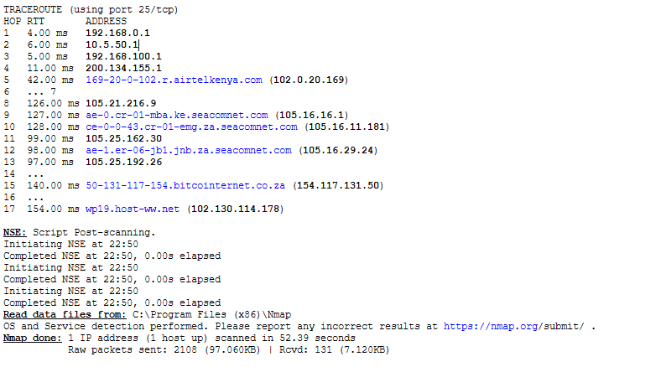Enumarate shared folders:
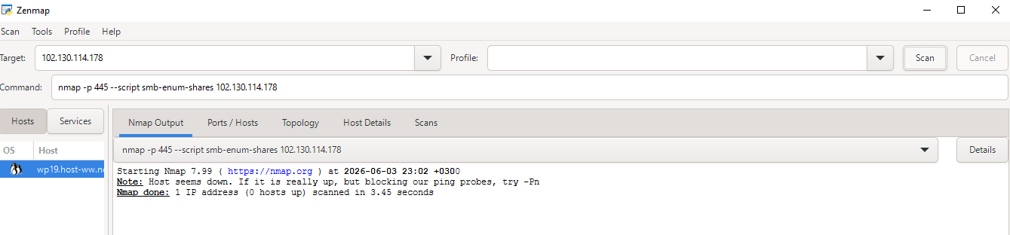
Student reflection:
What I have learnt while performing task 2,is how to identify live host of active work stations,open ports and operation system versions.Some of the challenges were that some ports were blocked so you could not get access to the information required.

